Important – Read Me First

Both projects mentioned in this book, require a programmer to take the following steps prior the start of project coding.

- Adding all components (.ocx files) required by each project individually
- Adding all library references (.tlb and .dll files) required by each project individually

Adding Components And References To a Project

To add new component to a project, click Project → Components from the menu bar. Refer to diagram A.1.

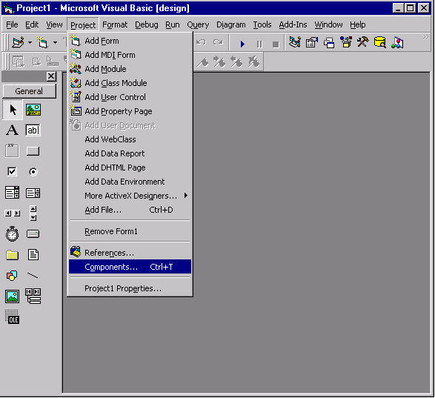

Diagram A.1

This will display a dialog box as shown in diagram A.2.

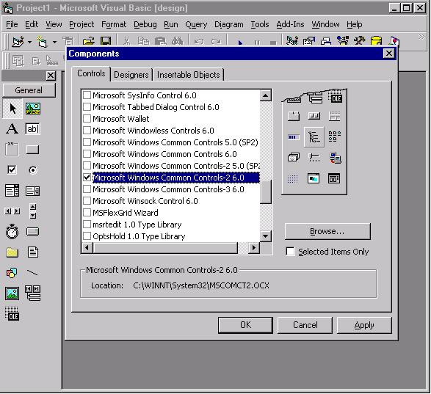

Diagram A.2

Select the required component by clicking on its check box (multiple components can thus be selected) then click Apply. Individual objects available in each new component will now be visible on the projects toolbar as shown in diagram A.3.

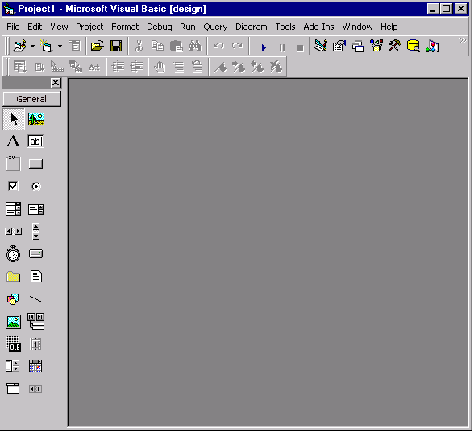

Diagram A.3

To add new library reference to a project, click Project → References from the menu bar. Refer to diagram A.4.

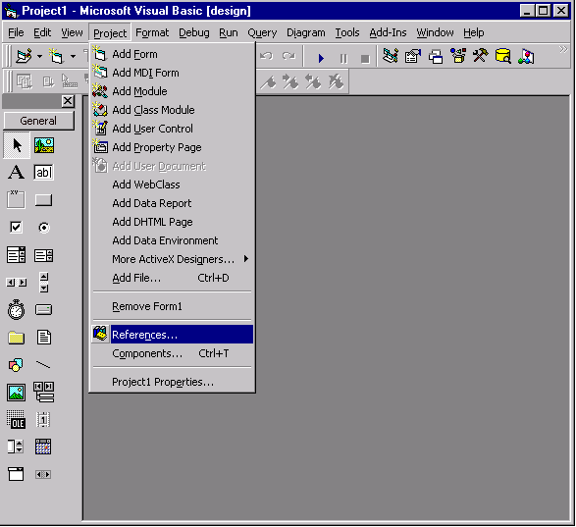

Diagram A.4

This will display a dialog box as shown in diagram A.5.

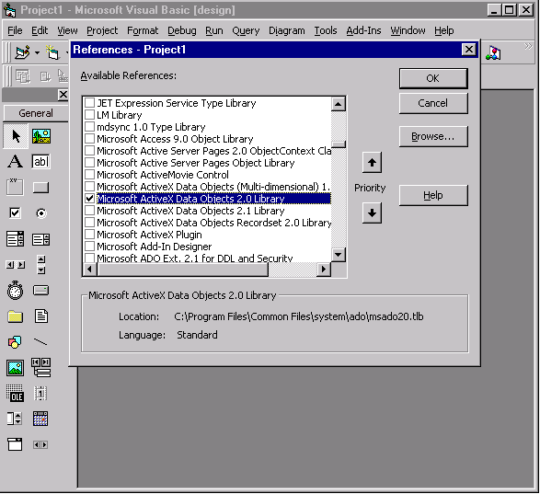

Diagram A.5

Click on the required checkboxes and then click OK.

